BUSINESS REQUIREMENTS,
Prepared for ClothingShop
Friday, January 05, 2024
Version 1.0

Prepared by
………………

Revision History
Date | Version | Author | Change Description
18/11/2023, 03:00 PM | 0.1 | Khai Ngo | Initial creation
20/11/2023, 11:16 PM | 0.2 | Khai Ngo | Define application overview
21/11/2023, 11:23 AM | 0.3 | Khai Ngo | Upload domain model
21/11/2023, 04:10 PM | 0.4 | Khai Ngo | Modify domain model
21/11/2023, 08:47 PM | 0.5 | Duong Dinh | Upload use case diagram
22/11/2023, 09:00 AM | 0.6 | Duong Dinh | Write description for use cases
23/11/2023, 10:41 AM | 0.7 | Duong Dinh | Modify use case diagram
21/12/2023, 1;27 AM | 0.8 | Duong Dinh | Modify use case diagram
05/01/2024, 9:03 PM | 1.0 | Khai Ngo | Modify use case diagram
Approval
Date | Version | Approver Name | Position
20/11/2023 | 0.1 |  | Application Owner
20/11/2023 | 0.1 |  | ITPM
21/11/2023 | 0.2 |  | Application Owner
21/11/2023 | 0.2 |  | ITPM
21/11/2023 | 0.3, 0.4, 0.5 |  | Application Owner
21/11/2023 | 0.3, 0.4, 0.5 |  | Application Owner
22/11/2023 | 0.6 |  | Application Owner
22/11/2023 | 0.6 |  | Application Owner
23/11/2023 | 0.7 |  | Application Owner
23/11/2023 | 0.7 |  | Application Owner
21/12/2023 | 0.8 |  | Application Owner
21/12/2023 | 0.8 |  | Application Owner
05/01/2023 | 1.0 |  | Application Owner
05/01/2023 | 1.0 |  | Application Owner

Table of Contents
1 Objective and Scope 4
2 Business Requirement 4
2.1. Application Overview 4
2.2. Domain Model 5
2.2.1. Diagram 5
2.2.2. Domain Objects Description 5
2.3. Workflow 7
2.4. Use Cases and Actors 7
2.4.1. Diagram 7
2.4.2. Description of Actors 8
2.4.3. Description of Use Cases 8
2.5. Security Matrix 9
2.6. User Story 11
2.7. Change Requirement 12
3 Appendix 13
3.1. Glossary 13
3.2. Open Issues 13

Objective and Scope
This document serves as the comprehensive Software Requirements Specification (SRS) and Design Document for the Omnichannel Retail & AI Platform project. The primary purpose of this document is to outline the software requirements and establish a clear design framework, providing a roadmap for application functionality, task assignment, and deployment strategies.
The scope of this document encompasses both the functional and non-functional requirements of the project. It defines how the applications under development will operate for Super Admins, Authorized Staff, and Customers, outlining features such as AI interactions, POS processing, and role-based access control.

Business Requirement

Application Overview
The Omnichannel Retail & AI Platform is a centralized, cloud-based retail management system designed to bridge physical in-store operations with a digital e-commerce storefront. The platform unifies inventory, sales, customer engagement, and staff management into a single cohesive ecosystem. Its primary goal is to eliminate data silos between online and offline sales while utilizing artificial intelligence to enhance the customer shopping experience and automate marketing efforts.
The system is logically divided into six core modules:
- Customer-Facing Web Storefront: A responsive e-commerce interface where customers can register accounts, browse the clothing catalog using advanced filters (size, color, price), securely checkout, track their orders, and leave photo-based reviews.
- AI Recommendation Engine (Chatbot): An integrated NLP (Natural Language Processing) chatbot that interacts directly with customers. It analyzes customer inputs regarding fit, style, and sizing to query the active catalog and return personalized, in-stock product recommendations that can be added directly to the cart.
- Omnichannel Inventory & POS Engine: The transactional heart of the platform. It handles physical Point-of-Sale (POS) transactions for in-store purchases and automatically synchronizes global inventory counts in real-time, preventing online overselling of out-of-stock items. It also handles the inventory logic for processed refunds.
- Order Fulfillment Module: A dedicated dashboard for Authorized Staff to view pending online orders, update statuses, attach shipping tracking numbers, and trigger automated customer notifications.
- Access Management & Security (RBAC): A highly granular, Super Admin-controlled module that restricts system access based on single-function custom roles. It includes a comprehensive, immutable audit logging system that tracks every staff and admin action across the platform for security and compliance.

- Social Marketing Integration: An automated marketing tool connecting the platform's catalog to Meta's Graph API. It allows staff to select active SKUs and auto-generate accurate, formatted Instagram posts directly from the system database.

Domain Model

Diagram
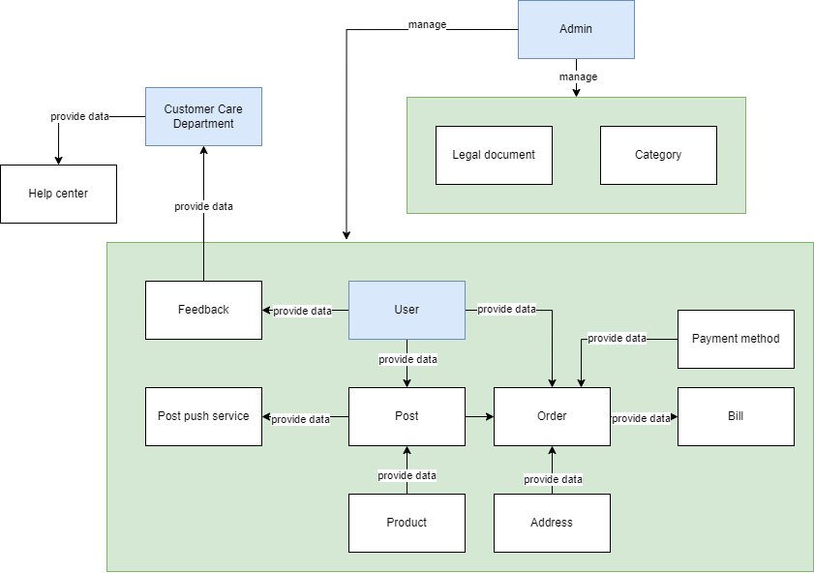

Domain Objects Description
# | Object Name | Object Description
1 | Admin | Users in this group have permission to manage user accounts, posts, legal documents, categories.
2 | User | Users in this group have permission to place order, manage their own posts, leave a feedback
3 | Customer Care Department | Users in this group have permission to view and handle feedback from all users.
4 | Legal document | The object contains the information of legal documents.
5 | Category | The object contains the information of categories
6 | Post | The object contains the post’s information.
7 | Order | The object contains the order’s information, created by the system when the user makes a purchase.
8 | Bill | The object contains the information of the order, buyer, seller and other needed information
9 | Payment Method | The object contains the information of payment method.
10 | Product | The object contains the information of product, just create when user creates a post.
11 | Address | The object contains the information of the shipping address.
12 | Post push service | The object contains the information of the post push service.
13 | Feedback | The object contains the information of feedback
14 | Help center | The object contains the information of help center

Workflow

Use Cases and Actors

Diagram
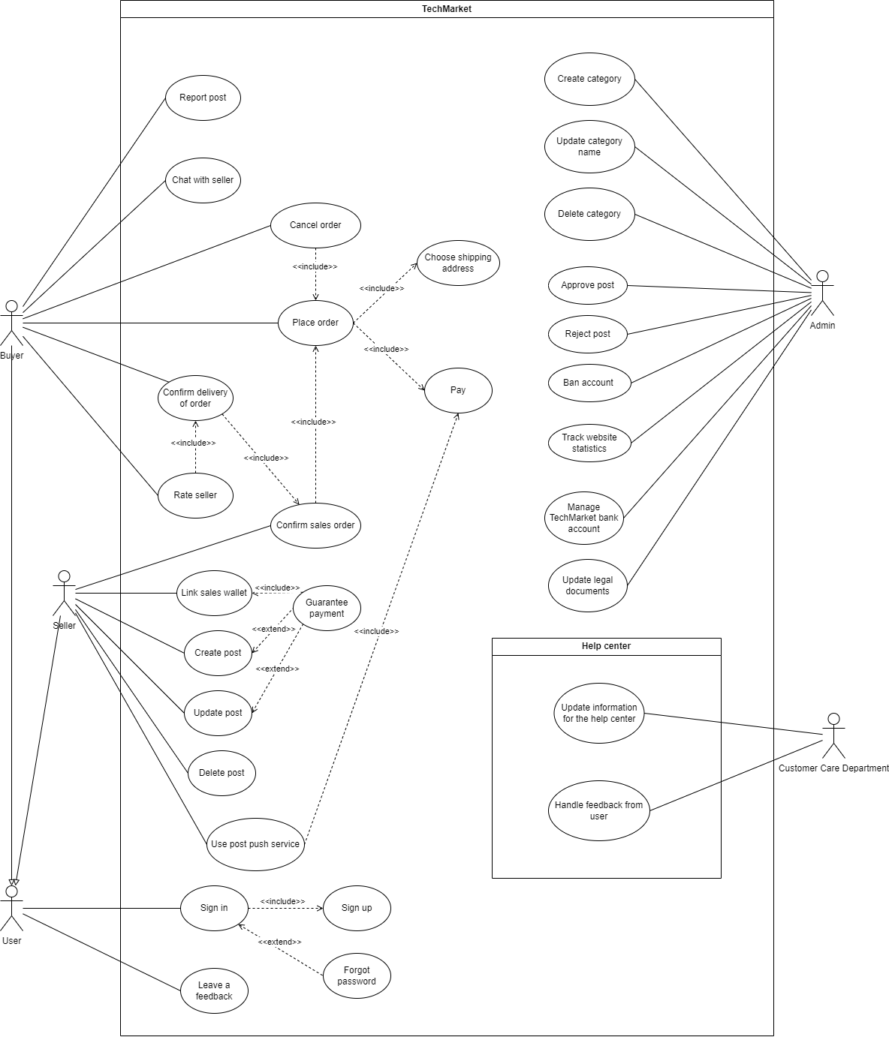

Description of Actors
# | Actor Name | Definition
1 | Admin | Administrator of the whole system, is responsible for order management and post management. Admin makes sure that posts and orders are valid.
2 | User | Who registers with the system
3 | Buyer | Users who want to sell their used electronic device
4 | Seller | Users who want to buy electronic devices
5 | Customer care department | Users who handle customer feedback and provide documents to the help center

Description of Use Cases
# | Use Case Name | Definition
1 | Sign In | This use case describes the process by which a user logs into the system.
2 | Sign Up | This use case describes the process by which a user creates a new account in the system.
3 | Forgot password | This use case describes how user can
4 | Leave a feedback | This use case describes how user can leave a feedback
5 | Create post | This use case descibes how user can create a post for selling electronic devices
6 | Update post | This use case describes how user can update a post
7 | Delete post | This use case describes how user can delete a post
8 | Guarantee payment | This use case describes how users can use guaranteed payment functionality for their posts
9 | Link sales wallet | This use case describes how a user can link to their merchant wallet
10 | Use post push service | This use case describes how a user can use the post push service, increase product sales.
11 | Confirm sales order | This use case describes how sellers can confirm the order of buyers.
12 | Place order | This use case describes how user can place an order for product they want to buy
13 | Choose shipping address | This use case describes how a user can select an existing address or create a new one
14 | Pay | This use case describes how users can pay for their payment
15 | Cancel order | This use case describes how a user can cancel an order
16 | Confirm delivery of order | This use case describes how buyer can confirm that they receive product
17 | Rate seller | This use case describes how buyer can rate the seller after receiving order
18 | Chat with seller | This use case describes how user can contact with seller for finding out more about the product
19 | Report post | This use case describes how users can report violative posts
20 | Create category | This use case describes how users can create new categories for the system
21 | Update category name | This use case describes how a user can change the category information
22 | Delete category | This use case describes how a user can delete a category
23 | Approve post | This use case describes how admin can approve a post to makes it visible on user’s wall
24 | Reject post | This use case describes how admin can reject a post due to the policy
25 | Ban account | This use case describes how a user can ban a user account that violates website’s regulations
26 | Manage TechMarket bank account | This use case describes how a user can manage a client's trading currency storage account
27 | Update legal documents | This use case describes how users can update legal documents related to a publicly available website
28 | Update information for the help center | This use case describes how users can update content and questions for the help center
29 | Handle feedback from user | This use case describes how users can view and respond to customer feedback

Security Matrix
Actor  Function | Admin | User | Buyer | Seller | Customer care department
Sign In |  | x
Sign Up | x | x
Forgot password |  | x
Leave a feedback |  | x
Create post |  |  |  | x
Update post |  |  |  | x
Delete post |  |  |  | x
Guarantee payment |  |  |  | x
Link sales wallet |  |  |  | x
Use post push service |  |  |  | x
Confirm sales order |  |  |  | x
Place order |  |  | x
Choose shipping address |  |  | x
Pay order |  |  | x
Cancel order |  |  | x
Confirm delivery of order |  |  | x
Rate seller |  |  | x
Chat with seller |  |  | x | x
Report post |  |  | x
Create category | x
Update category name | x
Delete category | x
Approve post | x
Reject post | x
Ban account | x
Track website statistic | x
Manage TechMarket bank account | x
Update legal documents | x
Update information for the help center |  |  |  |  | x
Handle feedback from user |  | x |  |  | x

User Story
As a Super Admin, I want to create a custom role so that I can define a specific, single-function job within the system.
As a Super Admin, I want to assign a single system permission to a custom role so that I can enforce strict role-based access control.
As a Super Admin, I want to assign a custom role to a staff account so that they can perform their designated function.
As a Super Admin, I want to revoke or modify a user's role so that I can securely manage system access when staff responsibilities change.
As a Super Admin, I want to view an audit log of all system actions so that I can track which user performed which function.
As an Authorized Staff member, I want to add new products and their associated variants (SKUs based on size/color) to the catalog so that they become available for purchase.
As an Authorized Staff member, I want to manually adjust the inventory count of specific SKUs so that the digital system accurately reflects physical stock discrepancies.
As an Authorized Staff member, I want to view a list of pending online orders so that I can prepare them for fulfillment.
As an Authorized Staff member, I want to update an order's status to shipped and add a tracking number so that the customer is notified.
As an Authorized Staff member, I want to generate and manage custom discount codes so that the business can run promotional campaigns.
As an Authorized Staff member, I want to link the platform to our Instagram accounts so that we can manage social media centrally.
As an Authorized Staff member, I want to auto-generate draft Instagram posts directly from catalog items so that marketing workflows are streamlined and product details match the database.
As an Authorized Staff member, I want to process a physical point-of-sale transaction so that in-store inventory is synced with the central database in real-time.
As an Authorized Staff member, I want to process a refund for a returned item so that the customer gets their money back and inventory is updated.
As a Customer, I want to register for a new account so that I can track my orders and save my shipping details.
As a Customer, I want to filter the clothing catalog by attributes (size, color, price) and seamlessly compare variant details so that I can easily find and evaluate items to buy.
As a Customer, I want to interact with the AI chatbot so that I can get personalized clothing recommendations and fit information.
As a Customer, I want to securely pay for the items in my cart so that I can complete my online purchase.
As a Customer, I want to view the availability of an item at different physical store locations so that I can decide where to shop in person.
As a Customer, I want to track the shipping status of my order so that I know when my package will arrive.
As a Customer, I want to leave a review and upload a photo of my purchased clothing so that other shoppers can see how it fits in real life.
As a Customer, I want to add an AI-recommended item directly to my cart.

Change Requirement
# | Item Name | Change Description
1
2
3
4
5
6
7

Appendix

Glossary
Term | Description
BRD | Business Requirements Document

Open Issues

